**Practical 1:**

**Install VirtualBox/VMware workstation with different flavours of Linux or windows OS on top of Linux/Windows**

**Step 1 –** Download VMware Workstation Player

First of all, you need to download from VMware from official website.

**Step 2 –** Run the installer

Start the installer by double clicking it. Then, you will see a splash screen. It will prepare the system for installation and then the installation wizard opens.

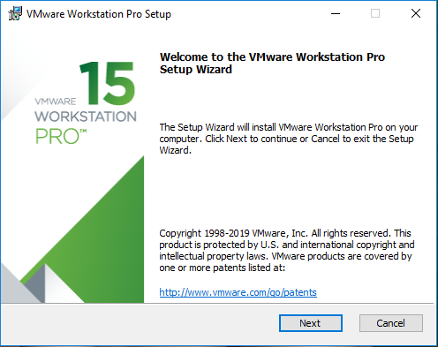

Click next and accept the license terms and click next again to move on to the next screen.

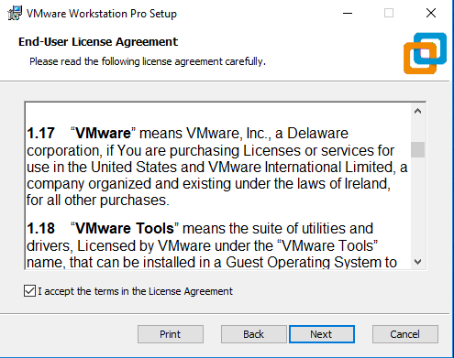

**Step 3 –** Custom setup

Enhanced Keyboard driver and Installation directory In this dialog box, please select the folder in want to install the application. leave it as it is. Also check the box Enhanced Keyboard Drivers option. Click next

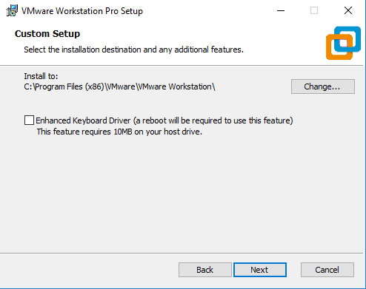

**Step 4 –** User Experience Settings

Check the options for Check the product update at Start-up and Join the VMware Customer Program. I normally leave it as it is. You can uncheck it if you so desire. Click next.

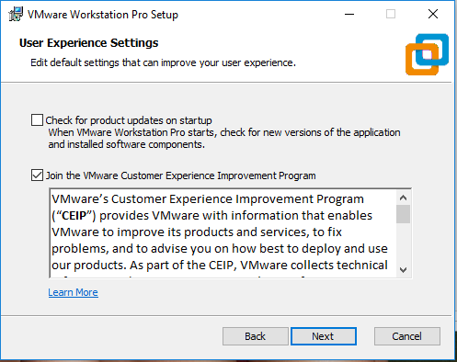

**Step 5 –** Select where the shortcuts will be installed

Check the box where the shortcut to run the application will be created. I leave it as it is.

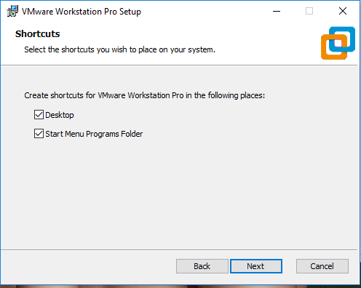

**Step 6 –** Ready to install

Now the installation wizard is ready to install. Click on install to begin the installation.

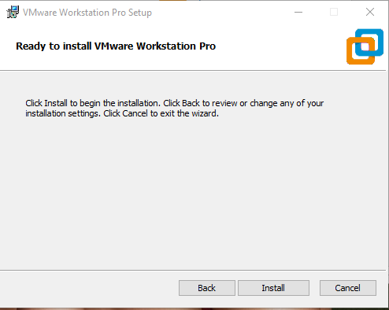

Installation begins, wait for it to complete. After sometime, you will see installation compete message. You are done.

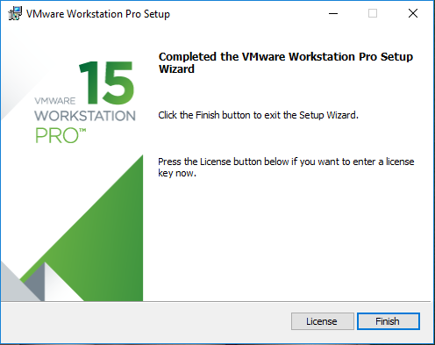

Click on Finish to Complete the installation. You will be asked to restart your system. Click on Yes to restart. Click No, if you want to restart later. But you must restart beforeusing the application, else some features will not work properly.

**Step 7 –** Licence

Now Run the application. You should see a desktop icon. Douple click on that or use thestart menu to navigate to VMware Player option. Once you run the application for the first time, you will be asked for licence. Select the option Use VMware Workstation Player 16 for for free for non commercial use. Click continue.

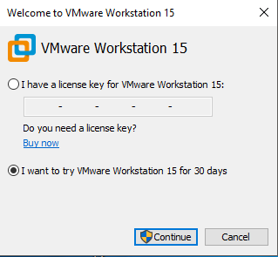

Click to Finish

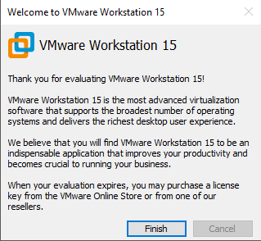

Now you will see VMware ready to be used for free for non-commercial purpose.

